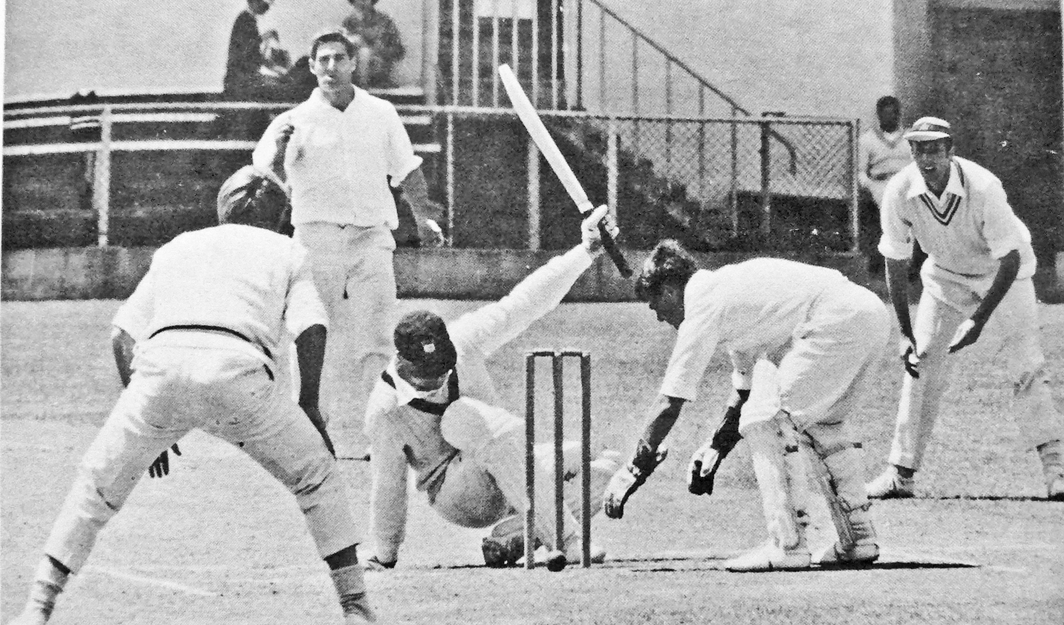 **Canterbury First Class Cricketers**

**Their Career and Achievements**

**Volume 7 1980 to 1992**

**Written and Compiled by Brian Adams**

**CANTERBURY CRICKET FIRST CLASS PLAYERS**

**VOLUME 7**

**NO 451 BD Thomas**

**To**

**NO 500 MB Owens**

**PREFACE**

This seventh volume contains the first class playing career and brief biographical notes of Canterbury cricketers from cricketer no 451 Barry Thomas to cricketer no 500 Michael Owens and covers the period from December 1980 until January 1992. The information has been obtained from a number of sources and without in any way being a complete list, it includes RT Brittenden’s history of Canterbury Cricket 1877-1977 and four other books he wrote on New Zealand cricketers. Other resources used were the histories of Christchurch cricket clubs including Riccarton, East Christchurch, St Albans, Lancaster Park, Burnside West Christchurch University, Sydenham and High School Old Boys. Mathew Appleby’s Canterbury Cricket 100 Greats was of value as well as the New Zealand cricket archive, the New Zealand rugby museum and Tony McCarron’s book on New Zealand cricketers. Dick Brittenden, while working at the Press newspaper, maintained a very complete record of club career records for all players competing in the Christchurch first grade competition.

However, although a number of records had been accessed, some were lost in the Christchurch earthquake of 2011. Many players spent time with me discussing their careers and some interesting and delightful stories came to light. I am grateful to them for the opportunity to learn more about the games they played and the effect that cricket had on their lives. Archive New Zealand was a source for many wills and divorce proceedings. The local papers often provided a vivid account of cricket politics at the time and many obituaries were sourced from those papers. Photos of players were obtained from many sources such as the files at The Press and Christchurch Star, the Canterbury Museum, the Christchurch city library, the Canterbury Club, the Hocken library, the Alexander Turnbull library, the photographic files of New Zealand Cricket Associations and the New Zealand Cricket Annual.

The details included for each player are the type of player he was, his school, his main club and his birth and death details when known. His playing record includes the match number, the date for the first day of the match, the opposition and where the match was played. Scores over 50 are in green, over a century in blue and five wickets in an innings are in red. A red c in the first column indicates he was captain for that match. A brief biography of their lives and an account of some of the matches played are also included. Direct quotations are in blue.

**CONTENTS**

1. Players first class record for Canterbury.
2. Players debut, birth, death, school, club, occupation.
3. Centuries scored, six wickets in an innings.
4. All match results from December 1980 to January 1992
5. Season averages from 1980/81 to 1991/92
6. Team photographs.
7. Players match by match performances and brief biography